Creation Of Jenkins file

A **Jenkinsfile** is a text file that defines a Jenkins Pipeline, which is a set of automated processes that help you build, test, and deploy your software. Here are some key points:

* **Automation**: It automates the steps of your continuous integration and continuous delivery (CI/CD) process.
* **Version Control**: Since it's a file, you can keep it in your source code repository alongside your application code.
* **Two Styles**:
  + **Declarative Pipeline**: Uses a more structured and simplified syntax, making it easier to read and write.
  + **Scripted Pipeline**: Provides more flexibility with Groovy-based code, useful for more complex scenarios.

Steps: -

# Right click on microservice Ex: - BookingMS

#Add New file as Jenkins file

# Add newly created groovy code or pipeline in the newly added Jenkins file

#Add and push newly created Jenkins file from local to remote using below git commands.

---git status

--git branch

--git add --all

--git commit -m “adding new Jenkins file”

--git push origin dev (push Jenkins file from locate to remote /dev branch)

# Login GitHub and check /dev branch newly added Jenkins file will be successfully pushed from local

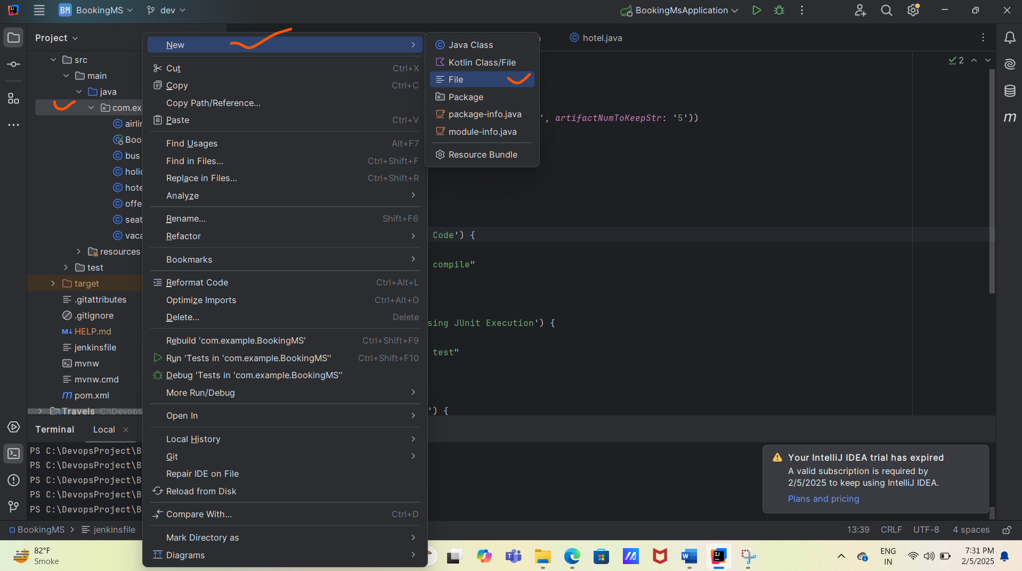

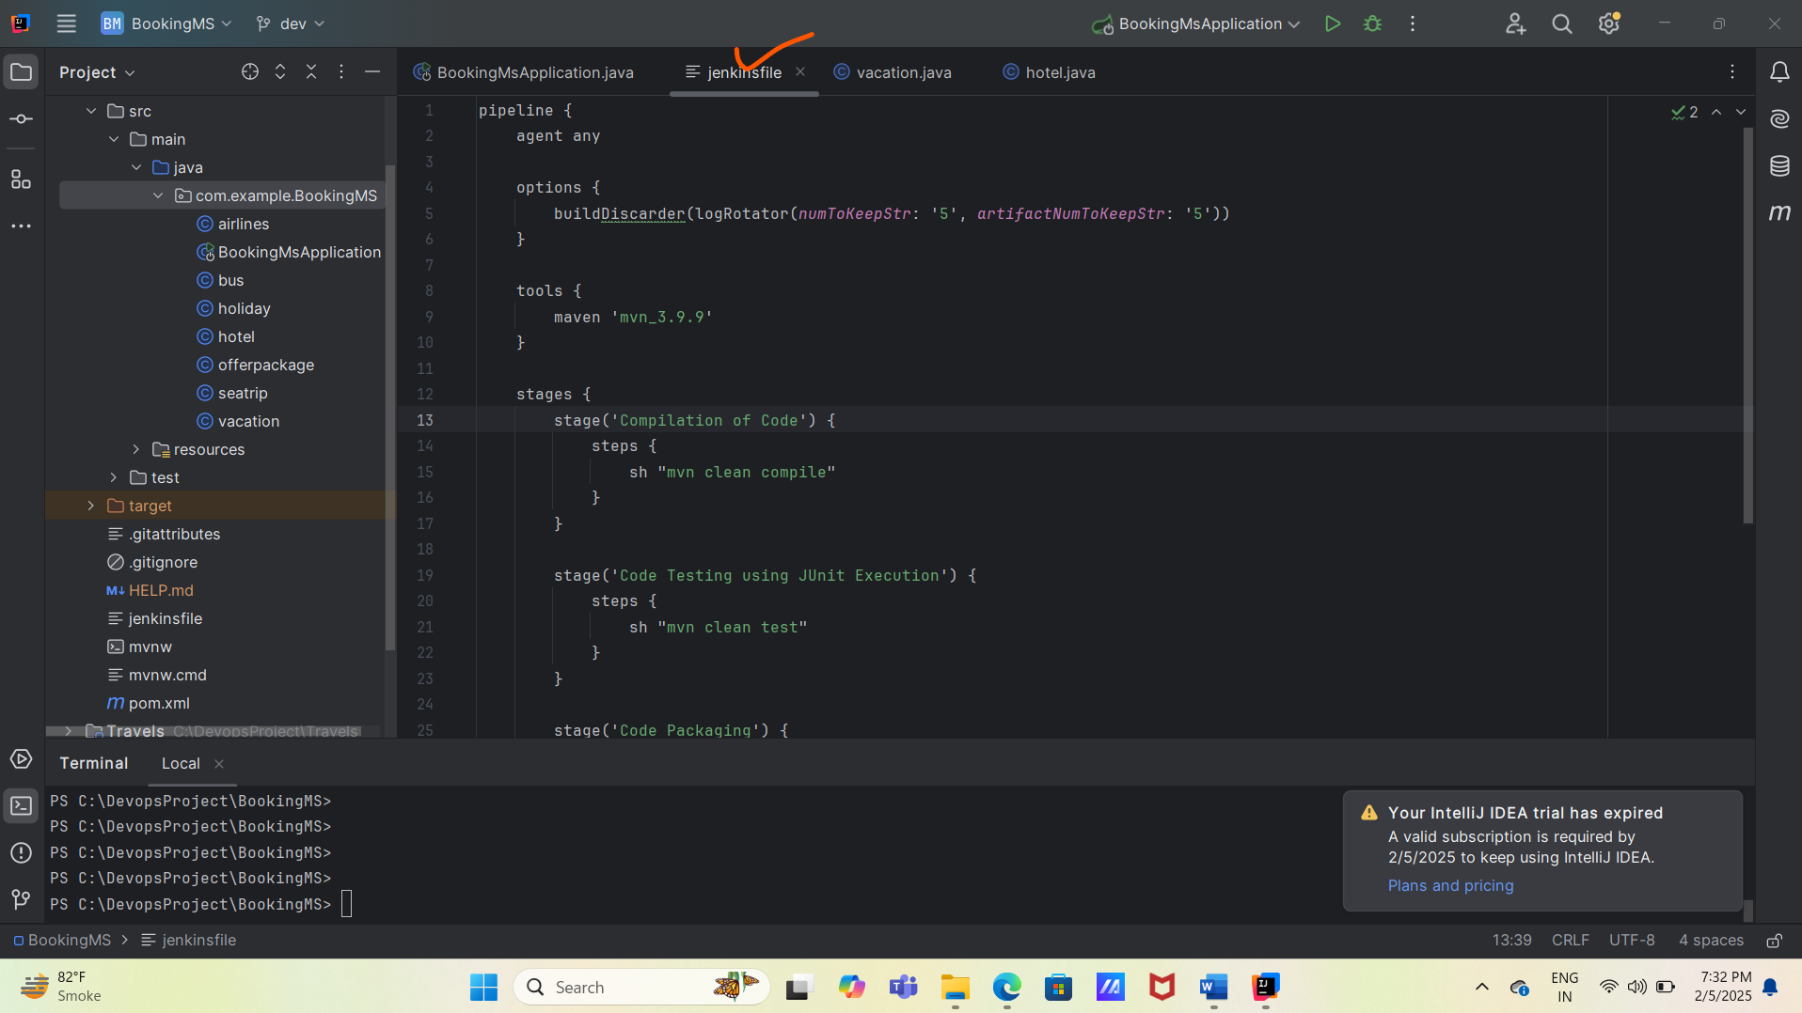

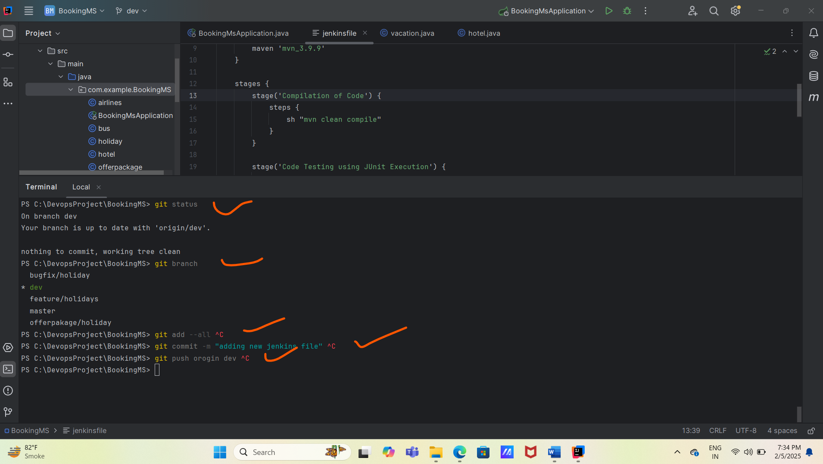

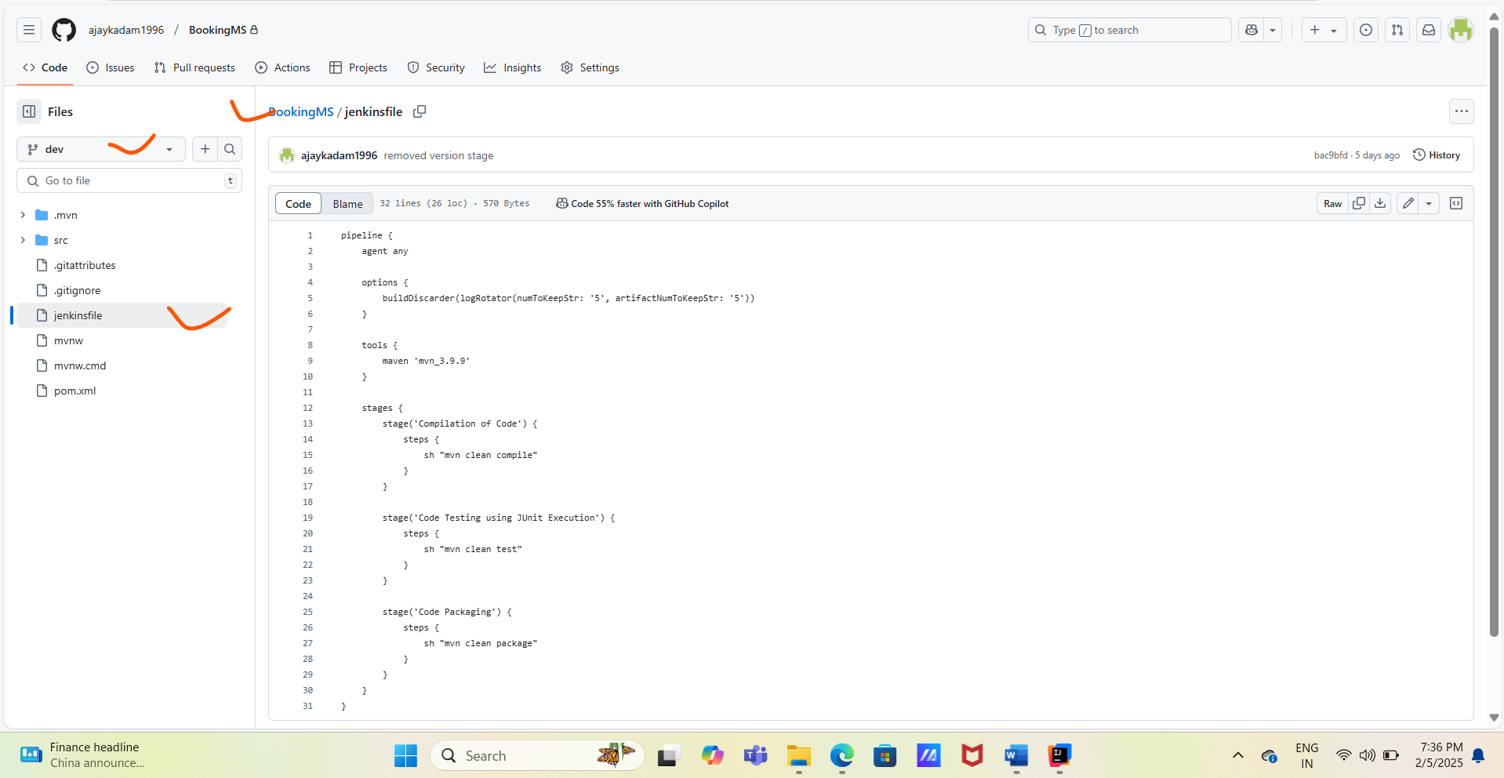

Pipeline / Groovy code: -

pipeline {

agent any

options {

buildDiscarder(logRotator(numToKeepStr: '5', artifactNumToKeepStr: '5'))

}

tools {

maven 'mvn_3.9.9'

}

stages {

stage('Compilation of Code') {

steps {

sh "mvn clean compile"

}

}

stage('Code Testing using JUnit Execution') {

steps {

sh "mvn clean test"

}

}

stage('Code Packaging') {

steps {

sh "mvn clean package"

}

}

}

}